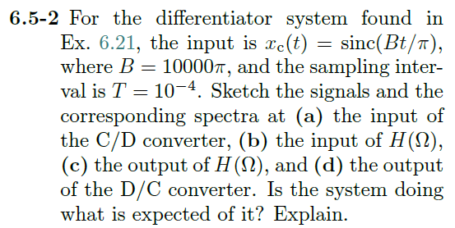

In example 6.21:

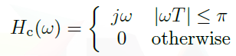

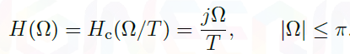

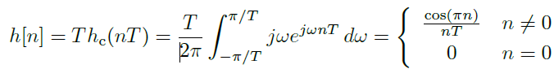

a) Input into C/D converter

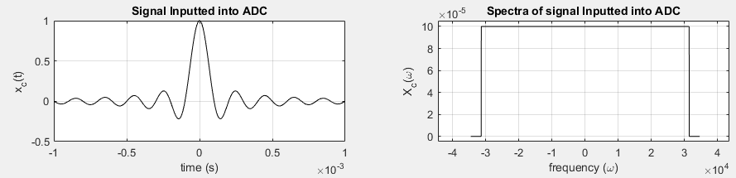

b) Input into $H(Ω)$

When sampled at 1ms, we end up with just a value of 1 at n = 0

Delta 🡨🡪 Constant

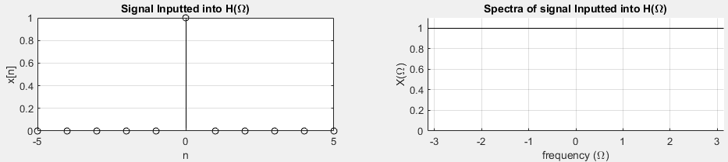

c) $y\left[n\right]=x\left[n\right]*h\left[n\right]=δ\left[n\right]*h\left[n\right]=h[n]$

From ex. 6.21 we know that $h\left[n\right]=\left\{\begin{matrix}\frac{\cos\left(πn\right)}{nT} n≠0 \\ 0 n=0\end{matrix}\right. and H\left(Ω\right)=\frac{jΩ}{T}$

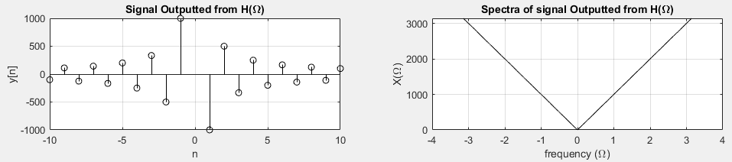

d) If we have ideal interpolation we can use eq. 4.2

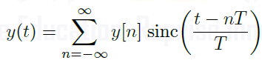

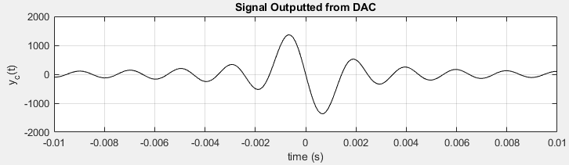

MATLAB:

cgate = @(t) (abs(t) < 0.5) + 0.5.*(abs(t) == 0.5);

ddelta = @(n) (n<0.000001 & n>-0.000001); % discrete Kronecker delta

B = 10000*pi; % Width of signal in time domain

T = 0.001; % sampling interval of 1 ms

DACmax = 3.3;

DACmin = 0;

xc = @(t) sinc(t.*B/pi); % Continuous time input

Xc = @(w) (pi/B).*cgate(w ./ (2*B));

x = @(n) xc(n.*T) .* (mod(n,1)==0);% Discrete time sampled signal

X = @(w) 1;

y = @(n) ((cos(pi.*n)./(n.*T)).*(n~=0) + 0.*(n==0)).*(mod(n,1)==0);

Y = @(w) w.*j/T .* (abs(w) <= pi);

%yc = @(t) DACmax.*(sinc(t.*B/pi) >= 0) + DACmin.*(sinc(t.*B/pi) <= 0);

% Sketch xc(t)

subplot(4,2,1); t = -T:T/1000:T;

plot(t,xc(t),'k'); xlabel('time (s)'); ylabel('x_c(t)');

title('Signal Inputted into ADC'); grid on;

% Sketch Xc(w)

subplot(4,2,2); w = -B-B/10:B/1000:B+B/10;

plot(w,Xc(w),'k'); xlabel('frequency (\omega)'); ylabel('X_c(\omega)');

title('Spectra of signal Inputted into ADC'); grid on;

% Sketch x[n]

subplot(4,2,3); n = -5:5;

stem(n,x(n),'k'); xlabel('n'); ylabel('x[n]');

title('Signal Inputted into H(\Omega)'); grid on;

% Sketch X(W)

subplot(4,2,4);

yline(1,'k'); xlabel('frequency (\Omega)'); ylabel('X(\Omega)');

title('Spectra of signal Inputted into H(\Omega)'); grid on; axis([-pi pi 0 1.1]);

% Sketch y[n]

subplot(4,2,5); n = -20:20;

stem(n,y(n),'k'); xlabel('n'); ylabel('y[n]');

title('Signal Outputted from H(\Omega)'); axis tight; grid on;

% Sketch Y(W)

subplot(4,2,6); W = -pi:0.001:pi;

plot(W,abs(Y(W)),'k'); xlabel('frequency (\Omega)'); ylabel('X(\Omega)');

title('Spectra of signal Outputted from H(\Omega)'); grid on;

% Sketch y(t)

N = 1000;

subplot(4,2,7); t = -0.01:0.0001:0.01;

yc = 0;

for n = -N:N

if n~=0

yc = yc + y(n) .* sinc((t - n*T)./T);

end

end

plot(t,yc,'k'); xlabel('time (s)'); ylabel('y_c(t)');

title('Signal Outputted from DAC'); grid on;

% Sketch Yc(w)

subplot(4,2,8); w = -B-B/10:B/1000:B+B/10;

% plot(w,Yc(w),'k'); xlabel('frequency (\omega)'); ylabel('Y_c(\omega)');

title('Spectra of signal Outputted from DAC'); grid on;